Espresso Coffee Maker
Instruction Manual

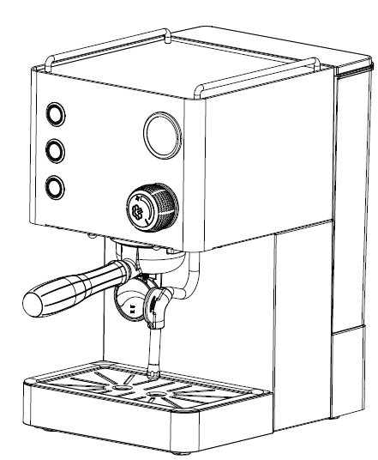

Item | AVX DB1 PLUS
Voltage | AC220-240V,50Hz/60Hz
Power | 1700W-2000W
Water tank | 1.7L
Pressure | 15Bar

*IMPORTANT SAFEGUARDS：
Before using machine always carefully read and comply with all these instructions. We cannot accept any responsibility for the consequences of improper use.
- Check voltage to be sure that the voltage indicated on the name plate agrees with your voltage.
- This appliance has been incorporated with a grounded plug. Please ensure the wall outlet in your house is well earthed.
- Close supervision is necessary when the appliance is used by people. Place the machine out of the reach of children and persons with limited capabilities.
- Do not place on or near a hot gas or electric burner or in a heated oven.
- Unplug from outlet when not in use and before cleaning. Allow to cool before putting or taking off parts, and before cleaning the appliance.
- Do not operate any appliance with a damaged cord or plug or after the appliance malfunctions, or has been damaged in any manner. Return appliance to the nearest authorized service facility for examination, repair or adjustment.
- The use of accessory attachment not recommended by the appliance manufacturer may result in fire, electric shock, or injury to persons.
- Be careful to ensure that the power cable does not become trapped and does not rub against sharp edges.
- Do not let the cord hang over the edge of a table or counter, or touch hot surfaces.
- If the power cord is damaged, to avoid danger, it must be replaced by professionals.
- Do not touch any hot parts. Use the handle of the funnel.
- To protect against fire, electric shock and injury to persons, do not immerse cord, plugs, or body of machine in water or other liquid.
- It must be protected against freezing conditions.
- Do not fill more than 1.7L to upper MAX mark, when pour water in water tank.
- Once the fault, defect or machine drop caused by suspicious defect, unplug the power plug immediately, do not operate on the problem machine.
- Do not use outdoors.
- Machine use condition: Room temperature: 0-55℃
- SAVE THESE INSTRUCTIONS FOR YOUR REFFERENCE.

*KNOW YOUR MACHINE

HOUSEHOLD USE ONLY
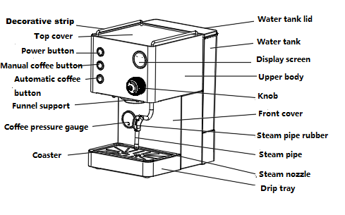

Product size:310X220X370MM

Warning: The machine must use a grinding Coffee powder and is composed of a central structure for obtaining espresso and steam/hot water. Others Non-standard Operation will cause danger.

*ACCESSORIES

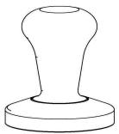  Tamper | 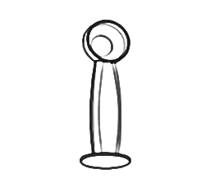  Coffee spoon | 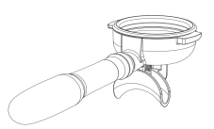  Double cup porta filter holder | Single cup filter

*OPERATION FUNCTION
Button | Name | Function
 | Power button | Turn on/Turn off machine
 | Manual coffee button | Making coffee/Stop making coffee
 | Automatic coffee button | Making coffee/Stop making coffee
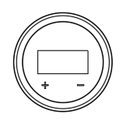 | Display screen | Temperature setting：  Turn on machine, long press“+”button 3s, value on display screen is flashing, you can press“+/-”to adjust the temperature, after setting for 5s, setting value will automatically save and machine return to standby mode.  Pre-infusion time setting:  Turn on machine, long press“-”3s, value on display screen is flashing, you can press“+/-”to adjust the pre-infusion time, after setting for 3s, setting value will automatically save and machine return to standby mode.(Defaut time 2s, setting range: 0-30s)

Operation instruction：
- For the first use, turn on the power button. After the machine automatically pumps water, turn on the coffee button to fill the water in the boiler (until there is water flowing out of the funnel support). Then turn off the coffee button, and the machine enters the preheating state.
2. When using, be careful of the parts with high temperature. Especially funnel support and steam pipe. Please do not put your hands on the above parts for any reason.

A. FOR THE FIRST USE
- Move the coffee maker from the package, and check the accessories according to the list;
- Clean all the detachable components;
- Operation the appliance according to the section of “B” and “D” (no coffee powder in filter). Repeat 2-3 times.

B. MAKE ESPRESSO COFFEE
- Open the lid, take out water tank, and pour appropriate water into tank. Do not exceed the MAX capacity;
- Put back the water tank and close the lid;
- Connect power plug, the machine will ring and all the lights and display screen will light on that means power connected. Press the power button, machine automatically pumps water for about 8s, power button and lamp keep lights on, the display showing the real-time coffee temperature, manual coffee button and automatic coffee button lights off, after pumping water, machine start preheating, manual coffee button and automatic coffee button flashing at the same time, the display showing the real-time coffee temperature and power button and lamp keep lights on, when all the buttons keep lights on, preheating is completed.
- Take out filter holder, pour appropriate coffee powder into the filter with coffee spoon, then press the coffee powder tightly, clean the extra coffee powder overflow the edge of holder, to avoid damage the seal ring of group head.
Note: If too much coffee powder remaining in the edge of the filter, will easily to cause poor sealing and water leakage.
- Hold the upper part of machine with hand, lock the filter holder counterclockwise into the middle of the group head (Handle direction is roughly perpendicular to the machine);
- Put cup(s) under coffee outlet;
- Start brewing by pressing manual coffee button or automatic coffee button and display screen start showing the brewing time.
- It will stop when you press the coffee button again or when the automatic coffee function reaches the setting time.
Warning: In the process of making coffee, don’t leave.
- Remove filter holder after finished, knock it out and clean it with hot water immediately, and lock it again for next use.

- How to make a good cup of coffee
Grinding coffee bean and grinding quality largely determines the quality of coffee, the time should be 25s-30s to make a cup of coffee, if the powder is too coarse, coffee extract inadequate, the taste is light, and color is lighter, the cream also will be very thin, and color is white; if the powder is too fine, coffee over extraction, it will be too dark, and no cream. A good cup of coffee should use freshly ground coffee beans (use burr coffee grinder), and use appropriate amount of coffee beans. Each time when you making coffee with coffee powder, the freshness of the beans is very important, long time storage will make coffee bean oil decomposition.

C. FROTHING MILK/ MAKE CAPPUCCINO
- Prepare espresso first with a large enough cup according to part “B. MAKE ESPRESSO COFFEE’’;
- Use whole, fresh cold milk out of the fridge(8℃-10℃), and pour 1/3 milk in cup;
Note: Use a stainless steel cup, and cup diameter should not less than 70 ± 5mm, due to the volume of milk will increase after frothing.
- Put a stainless steel cup under steam nozzle;
- Open steam knob, rotate it to the maximum position to frothing milk;
- Remove cup when desired milk foam reached, then turn off knob, steam is stopped, pour the frothed milk into prepared espresso, now cappuccino is ready, you can add some sugar or Coco powder if you like it.
Note: Purge steam to clean steam nozzle after use, warning hot surface.

D. HEATING LIQUID (Steam function)
7
1. Use a stainless steel cup, pour cold liquid to 1/2 cup;
Note: Cup diameter should not less than 70 ± 5mm.
- .Put a cup under steam nozzle;
3. Turn on steam knob, release steam, let steam nozzle insert into the liquid;
4. Turn off the knob when desired temperature is reached, now steam is stopped, open knob again if you want to continue making steam;
Note: Clean steam nozzle immediately after use, to prevent milk scaling.
Caution high temperature of hot water outlet when in use.

E. BOILER TEMPERATURE AND AUTOMATIC COFFEE TIME SETTING
1. Setting boiler temperature: long press “+”on the display about 3s, then the number in the display flashing, then press “+” or “-” setting temperature, waiting about 5s to confirm, setting value will automaticlly save and machine return to standby mode(Default 95℃, Setting range: 80-102 ℃);
2. Automatic coffee time setting: long press the automatic coffee button, the display starts to count by seconds, if it reaches your required time, release the automatic coffee button and the time is set successfully. (Setting range is 10-120s);
3. Pre-infusion time setting: Press and hold the "-" button on the display screen for about 3 seconds, and the number on the display screen will flash. Click or hold the "+" or "-" button to set the temperature value. After setting it, wait for about 5 seconds for the machine to automatically confirm the changed temperature value, save the settings, and return to standby mode. The adjustable range is 0-30 seconds; The default time is 2 seconds.
4.Pre-filling time setting: long press the manual coffee button " " for about 3s, the number in the display flashes, tap or long press "+" or "-" to set the temperature value, after setting, wait for about 5s The machine will automatically determine the changed temperature value, and automatically save the settings and return to the standby state, the setting range is: 1-30s; The default time is 1s.
5. Restore default: Press automatic coffee button and manual coffee button for about 3s, display screen flashing “888” about 5s, machine restore default setting time.

*TROULBE SHOOTING
Problem | Cause/Result | Solution
No water comes out | Water tank is empty | Pour water in water tank
No water comes out | The input voltage or frequency is inconsistent with nameplate | Make sure the voltage and frequency is consistent with the nameplate
No water comes out | Machine malfunctions | Please contact with the authorized service
No steam is generated | Steam nozzle clogged | Clean steam nozzle
No steam is generated | Water tank is empty | Pour water in water tank
No steam is generated | Machine malfunctions | Please contact with the authorized service
Coffee runs out around the edge of the filter holder | Too much powder in the filter | Turn off the machine and wait for it cool down, clean the filter, then pour appropriate coffee powder
Coffee runs out around the edge of the filter holder | There is powder in the seal ring under group head
Coffee runs out around the edge of the filter holder | Implementation of the above operation problems still exist | Please contact with the authorized service
Coffee comes out too slow or no coffee comes out | coffee powder is too fine, and clogged filter | With thicker coffee powder
Coffee comes out too slow or no coffee comes out | Filter holes are blocked | Brush / clean the filter
Coffee comes out too slow or no coffee comes out | Water tank is not inserted | Insert the water tank in place
Water leakage on the bottom of machine | Drip tray is filled up | Please clean the drip tray
Water leakage on the bottom of machine | Machine malfunctions | Please contact with the authorized service
Machine is not working | The power cord is not plugged well. | Plug the power cord into a wall outlet correctly,
Machine is not working | NTC is short circuit | Please contact with the authorized service
Machine is not working | Machine malfunctions | Please contact with the authorized service
The steam cannot froth. | Steam indicator not light on | Wait steam indicator lights on.
The steam cannot froth. | The container is too big or the shape is not fit | Use high and narrow cup or garland cup
The steam cannot froth. | Used skimmed milk | Use whole milk
Display show E1 | NTC of coffee boiler is short circuit | Check whether room temperature is lower than 0℃/Please contact with the authorized service
Display show E4 | NTC of steam boiler is short circuit | Check whether room temperature is lower than 0℃/Please contact with the authorized service
Display show E6 | Opening the steam knob without resetting/releasing steam for more than 300s | Reset the steam knob
*If you have not been able to solve the problem, contact customer support in your country.

-

*CLEAN AND MAINTENANCE
- The machine has to be switched off and cooled down;
- Clean housing with damp cloth;
Note: Do not use abrasive sponges and alcohol or solvents.
Do not immerse the machine into water.
- Clean steam outlet, confirm there is no blockage;
- Clean the outlet and the seal sing under the group head with professional brush;
- Rinse with hot water to dissolve any coffee bean oil residue;
- Clean all the detachable attachments in the water and dry thoroughly.

*CLEANING MINERAL DEPOSITS
- The machine builds up lime scale deposits over time, and you need descale the machine 2-3 months;
- Pour water and descale in water tank up to MAX capacity (water and descale ratio is 4:1, follow the instruction of descale. Please use “household descale”, or you can use the citric acid replace descale (water and citric acid ratio is 100:3);
- Lock the filter holder (no coffee powder) into the group head. According to part “B” MAKE ESPRESSO COFFEE;
- Press coffee button, then make about 150ml coffee after coffee indicator always lights on, turn off coffee button and turn on steam button, then open knob after steam indicator always lights on, release steam about 2min and turn off the knob, then make descales deposit in the machine at least 15min;
- Repeat the steps 4 for 3 times;
- Press coffee button to brew coffee until there is no descale left;
- Make coffee again(no coffee powder), repeat the steps 4 for 3 times (no need wait for 15 min), then brewing until no water is left in the boiler;
- Repeat the step 7 at least 3 times to make sure the piping is cleanly.

*ANTIFREEZE STEPS
Note: if the temperature of the coffee machine is lower than the freezing point, it will cause damage to the equipment, In order to prevent the coffee machine from freezing and cracking during transportation or storage, the following steps must be followed before the coffee machine is shut down:
1. When the coffee machine needs to be shut down after use, take out the water tank from coffee machine first;
2. After taking out the water tank, press the coffee button to let the water out of the water outlet for 10 seconds, and then close the coffee button;
3. Turn off the coffee power after following the above steps;
4. Before using the coffee machine next time, install the water tank and operate normally.

*DISPOSAL
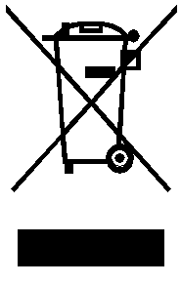
Please dispose of old machines in an environmentally neutral way.
Old machines contain valuable materials which should be salvaged for recycling. Please therefore dispose of old machines via your regional collection system.

